Nama : Ade Neviyani

NIM : 19051397018

Prodi : D4 RPL A’19

TUGAS BINARY TREE
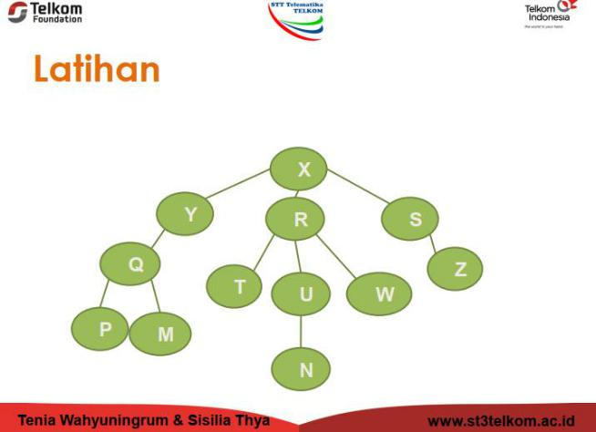

1. | Ancestor (T) | = R,X
2. | Descendant (R) | = T,U,W
3. | Parent (P) | = Q,Y
4. | Child (X) | = Y,R,S
5. | Sibling (T) | = U,W
6. | Size | = 12
7. | Height | = 4
8. | Root | = X
9. | Leaf | = P,M,N,Z
10. | Degree (R) | = 3

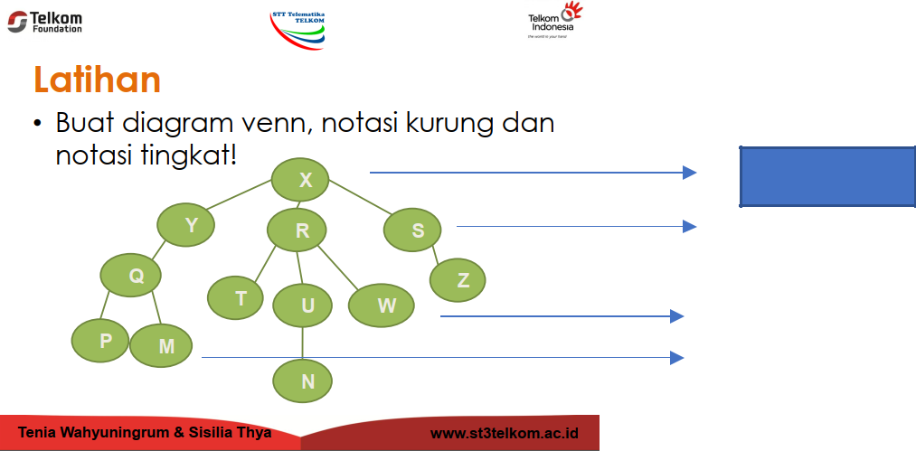

Tingkat 0

Tingkat 1

Tingkat 2

Tingkat 3

- Diagram Venn
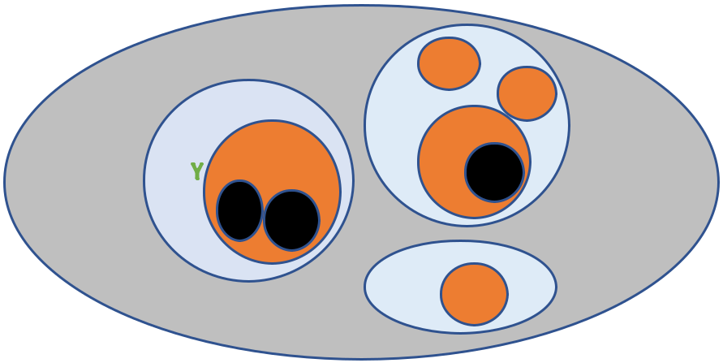

 |  |  | T
 |  |  | W
 |  |  | R
X |  |  | U
X |  | Q | N
 | P |  | M
 |  |  | S
 |  |  | Z

- Notasi Tingkat

X

Y

Q

P

M

- T U

N

W

S

Z

- Notasi Kurung (X(Y(Q(P,M)),R(T,U(N),W),S(Z)))
IDENTIFIKASIKAN!
1. | Ancestor (N) | = U,R,X
2. | Descendant (Y) = Q
3. | Parent (Z) | = S
4. | Child (Q) | = P,M
5. | Sibling (U) | = T,W
6. | Size | = 12
7. | Height | = 4
8. | Root | = X
9. | Leaf | = P,M,N,Z
10. | Degree ® | = 3
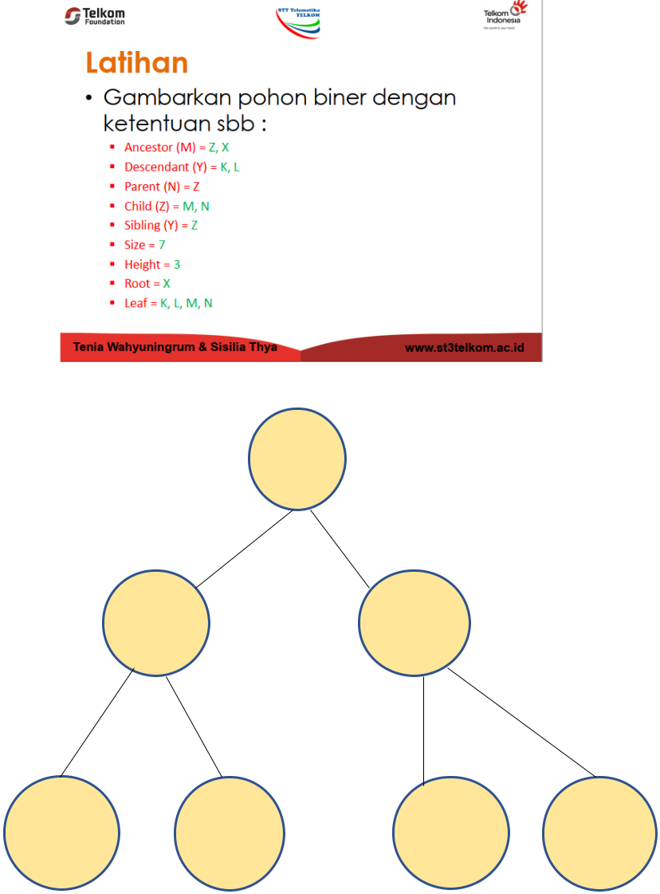

X

Y Z

K L M N
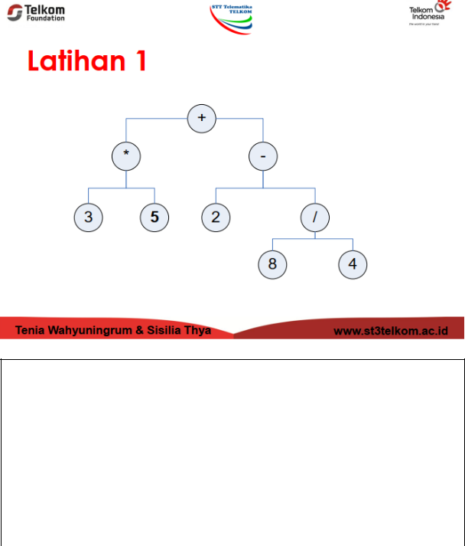

- Preorder:
+*35–2 /84

- Inorder:
35*+284/-

- Postorder:
35*284/-+
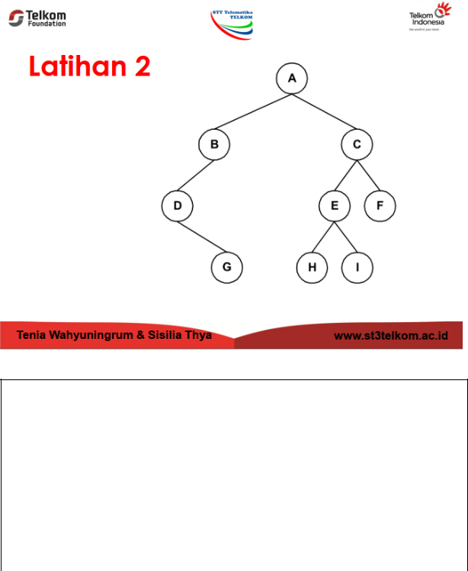

- Inorder:
DGBAHIECF

- Preorder:
ABDGCEFHI

- Postorder:
GDBHIEFCA

